Mechanical Overview

Year: 2022 Semester: 2 Team: 2 Project: VRms

Creation Date: February 2, 2022 Last Modified: February 2, 2022

Author: James Donnelly Email: donnell9@purdue.edu

Assignment Evaluation:

| **Item** | **Score (0-5)** | **Weight** | **Points** | **Notes** |
| --- | --- | --- | --- | --- |
| **Assignment-Specific Items** | | | | |
| **Commercial Packaging Analysis 1** |  | x2 |  |  |
| **Commercial Packaging Analysis 2** |  | x2 |  |  |
| **CAD Model Illustrations** |  | x4 |  |  |
| **Project Packaging Specifications** |  | x2 |  |  |
| **PCB Footprint Layout** |  | x2 |  |  |
| **Writing-Specific Items** | | | | |
| **Spelling and Grammar** |  | x2 |  |  |
| **Formatting and Citations** |  | x1 |  |  |
| **Figures and Graphs** |  | x2 |  |  |
| **Technical Writing Style** |  | x3 |  |  |
| **Total Score** |  | | |  |

5: Excellent 4: Good 3: Acceptable 2: Poor 1: Very Poor 0: Not attempted

Comments:

1. Commercial Product Packaging

For our commercial product packaging analysis, we looked at two products currently on the market: the myCobot Pro robot arm [1] and the Jaco robot arm [2]. As these products are aimed at completely different markets, they will provide us with unique perspectives for creating a project such as ours.

* 1. Product #1: myCobot Pro

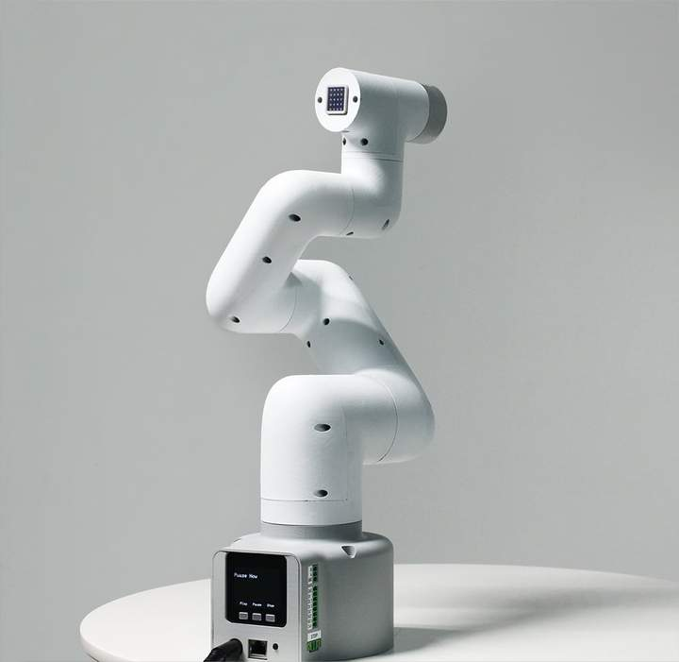

This robot arm is meant for assembly line automation, and features a robust design aimed at durability and reusability. The internals of the arm are fully enclosed, allowing for maximized safety in possibly dirty working environments, as the motors and other hardware will be protected from anything that might be in the environment. The control unit and user interface is packaged below the arm, which will increase the reliability of the hardware since this way the most important components will be kept stationary while the arm moves.

While the design is well suited for a factory environment, some aspects of its packaging might be detrimental to our particular application. For example, while the outer casing that encloses the internals of the arm provides increased safety, it takes extra material to do so and would require a lot of effort to make a custom housing that would completely enclose our arm without hindering its movement. Since our arm is going to be built for demo purposes and since we will be operating in clean environments, our prototype will be packaged more as a skeleton, and we will leave the motors exposed.

* 1. Product #2: Jaco

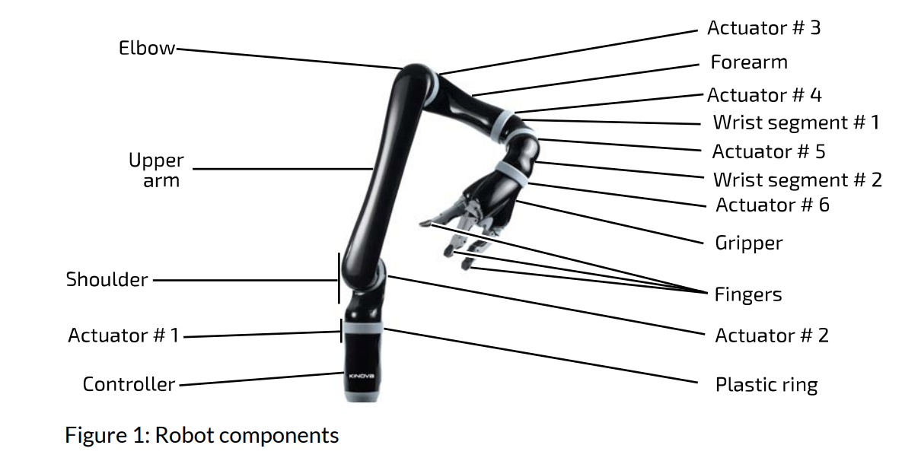

This arm is meant to be an assistant for people with limited functionality in their arms. Unlike the myCobot Pro’s robust design, this arm is built to mimic the look and movement of a human arm. However, similarly to the myCobot pro, it features completely enclosed hardware with a control unit within the base below the moving parts of the arm, with elbow and wrist joints as well as finger-like grabbers for the manipulation of everyday items. Packaging the arm to physically represent a human arm would help its users better translate the motion and functionality of a human arm into the robot’s movements.

While a human-like design is ideal for mimicking a human arm, this would create a considerable design challenge for us as we are using a robot arm that is generically shaped as opposed to being shaped like a human arm. It would require a lot of work alongside making or ordering custom parts to convert and package our arm into something like this example. Using a grabber that anatomically resembles a hand would further increase the complexity of this redesign.

2.0 Project Packaging Description

Similar to the above designs, our arm will feature a control unit housed beneath the moving parts of the arm. As opposed to the above designs, we will be leaving our arm in a skeleton form instead of fully enclosing the motors in the joints. In addition, we will be further simplifying the hand from using multiple fingers (as seen in the Jaco arm) to a pincher for manipulating objects. While straying from the design of a human arm may seem harmful to the effectiveness of our product, during our simulations in VR, we determined that the shape of the arm itself didn’t have much of an effect on its usability for our purposes, so we are confident that a simpler packaging of the arm itself will not reflect negatively on its usability.

The PCB and other hardware within the control unit can be housed in a simple box for protection stored on the base, with an opening for any needed cables or connection to the arm. The camera unit will be housed in a similar way, as it will be mounted above the arm and offset slightly to the side to provide a human-like perspective to the VR environment and will be stored within the plastic housing that came with the camera unit. Since the robot arm will be exposed, the base of the arm was provided to us, and the camera housing came with the camera unit, the only packaging that we will need to custom make will be the box for the PCB and other hardware.

3.0 Sources Cited

[1] “Robotics suction pump,” *Oz Robotics*. [Online]. Available: https://ozrobotics.com/shop/mycobot-pro-1kg-payload-commercial-6dof-collaborative-robot-arm/. [Accessed: 04-Feb-2022].

[2] “JACO® Assistive Robot User Guide - Kinovarobotics.com.” [Online]. Available: https://www.kinovarobotics.com/uploads/EN-UG-007-Jaco-user-guide-R05.pdf. [Accessed: 04-Feb-2022].

Appendix 1: CAD Model Illustrations

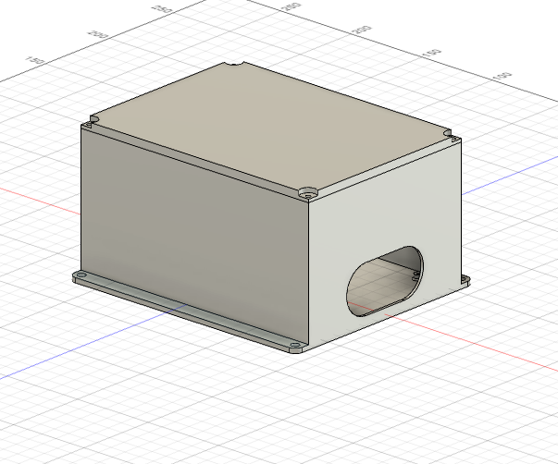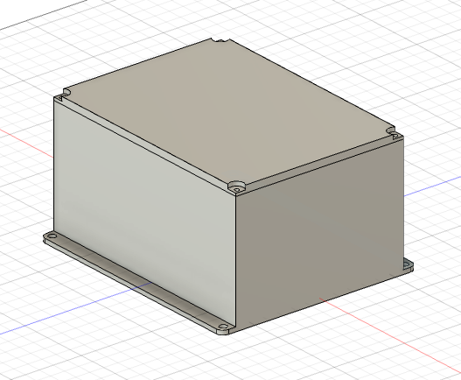

Dimensions

Length: 13cm Width: 10cm Height: 8cmAppendix 2: Project Packaging Specifications

| **Material** | **Tools Required** | **Weight** | **Cost** |
| --- | --- | --- | --- |
| PC-Max (3D Print) | 3D Printer | 232g | $0 |
| Bolts | Drill | 4g | $1 |
| Nuts | NA | 4g | $1 |

Appendix 3: PCB Footprint Layout

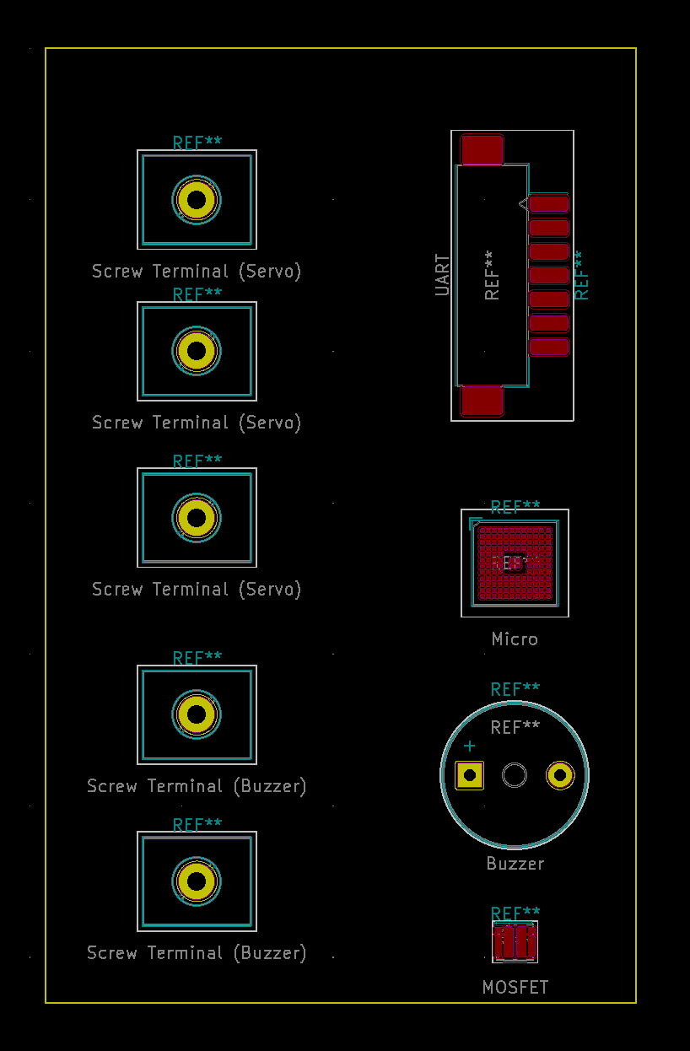

Dimensions:

Length: 8cm Width: 5cm